**Drop Required User DB’s – (2) -- SQL Server.**

--Below TSQL Script will kill all DB connections and delete all databases in the list.

**--Ensure that before Dropping any DB, please take a Full DB Backup for safer side.**

**--Before dropping the below mentioned user databases.**

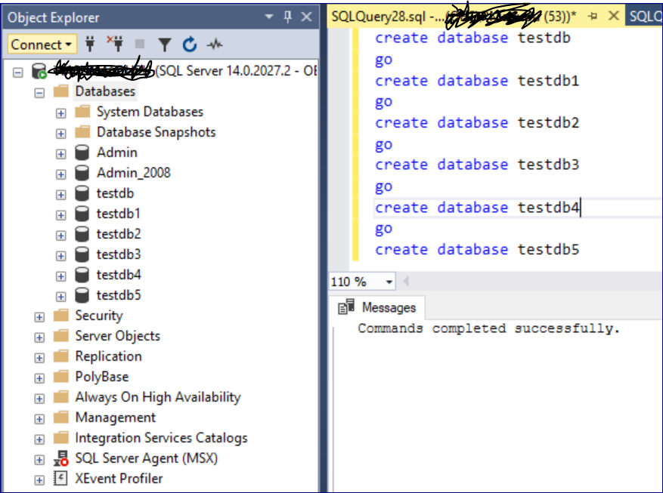

use [master]

go

DECLARE @DATABASENAME nVARCHAR(20)

DECLARE @TABLE TABLE (NAME NVARCHAR(100))

Declare @SQL nvarchar(100)

INSERT INTO @TABLE

SELECT name

FROM sys.databases

WHERE name in **('testdb','testdb1','testdb2','testdb3','testdb4','testdb5')**

--specify the exact DB Names in above line which needs to be dropped.

while (select COUNT(*) from @table) > 0

begin

select @DATABASENAME = (select top 1 (name) from @TABLE)

DECLARE @kill varchar(8000) = '';

SELECT @kill = @kill + 'kill ' + CONVERT(varchar(5), spid) + ';'

FROM master..sysprocesses

WHERE dbid = db_id(@DATABASENAME)

EXEC(@kill);

set @SQL = 'drop database ' + @DATABASENAME

exec sp_executesql @SQL, N'@databasename nvarchar(100)', @databasename;

Print @databasename + ' has been deleted'

delete from @TABLE where NAME = @DATABASENAME

end

**--After dropping the above-mentioned user databases.**

